AutoHotkey

Setup

1. Locate AutoHotkey installer:
   1. http://ahkscript.org/
2. Run AutoHotkey installed
3. Download script:
   1. Click [File link](https://rawgit.com/Pjmcnally/slw/master/autohotkeys/auto_upload.ahk)
   2. Right click in new window
   3. Click “Save As”
   4. Save in “My Documents”
   5. Rename file “AutoHotkey.ahk”
   6. If other scripts are needed Files are hosted on my [Github](https://github.com/Pjmcnally/slw/tree/master/autohotkeys).
4. Copy link of AutoHotkey.exe to Startup folder
   1. There is not internal option to make AutoHotkey run at windows start

Issues

AutoHotkey has not been fully deployed. I have not been able to do full testing so I do not know exactly which ways things will break or users will have issues. However, I do know of a couple possible issues and how best to solve them.

If a Hotkey goes awry it will continue to attempt to execute its command until it has complete itself. This can be cancelled by right clicking on the AutoHotkey log in the taskbar and selecting “Reload this Script”. This essentially resets AutoHotkey back to as if it had just run. If you make any changes to a script you must also “Reload this script” before AutoHotkey will acknowledge those changes.

The main issue I have been dealing with is AutoHotkey going too fast and having the commands jumbled or misinterpreted by the browser. This can manifest in several ways but the most typical is that it will not upload the correct number of references instead it simply keeps overwriting one of them. I have attempted to force the Hotkey to slow down enough to ensure that this isn’t a problem but I have not been able to fully test the solution.

Bulk Upload instructions

1. Have references ready to file.
   1. The references MUST be bulk renamed using SideBar. If they are not AutoHotkey will not work.
   2. I also Bulk Flatten all references however this step is not necessary.
   3. The references must all be located in one folder. Ideally no other files should be in the same folder.
2. Navigate to USPTO EFS and begin filing.
3. When you are ready to upload the references click “Browse”

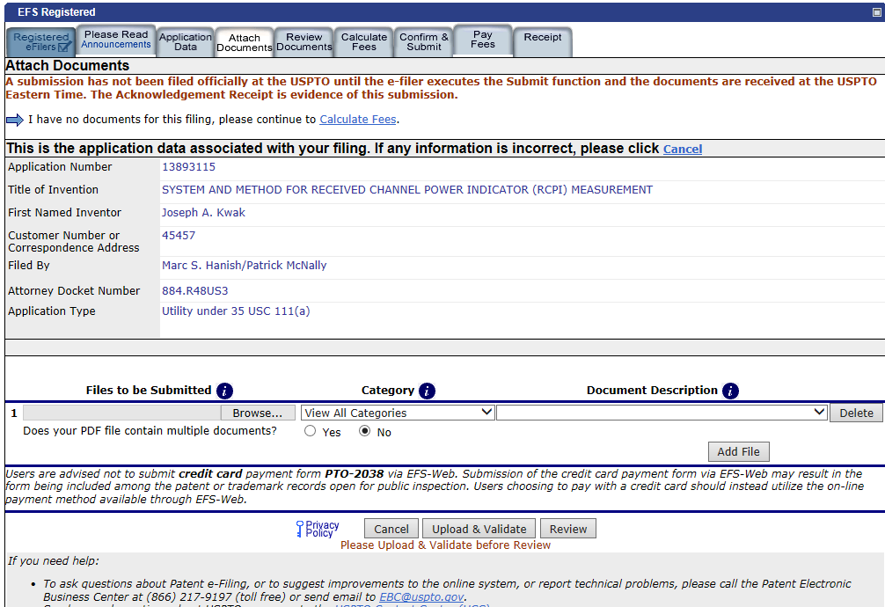

CLICK HERE

DO NOT CLICK HERE

1. In the box that pops up navigate to the folder with the documents
2. Click in the file name box so the cursor is blinking there
3. Press the Hotkey
   1. Press Windows Key + i if you are using Internet Explorer
   2. Press Windows Key + c if you are using Chrome
   3. Press Windows Key + x if you are using Firefox
4. Answer the questions
   1. Please note that you can still only submit 20 references at a time.
5. Don’t touch anything
   1. While AutoHotkey is working if you type or click anywhere you can disrupt it
6. Read the final message and check to make sure the number of references uploaded matches the number is the message.
7. Click “Upload and Validate”